**Terrorist Camp - Philippines**

**U.S. Embassy News Release**

**June 27, 2007**

**U.S. Admiral Visits Former Terrorist Camp in Sulu,**

**Congratulates AFP for Successes**

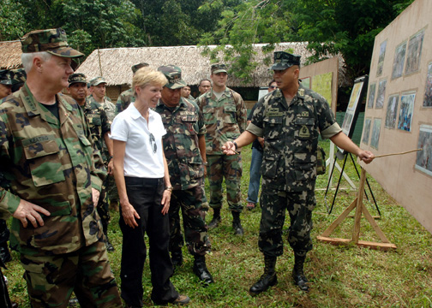

Adm. Timothy J. Keating, Commander, U.S. Pacific Command (PACOM) and U.S. Ambassador Kristie A. Kenney visited a former terrorist stronghold June 26 at Tugas Hill, Sulu Province to view first-hand a significant battle site in the Philippines’ fight against terrorist organizations.

The tour was part of Adm. Keating’s five-day visit to the Republic of the Philippines in his new role as PACOM Commander.

In September 2006, Abu Sayyaf terrorist leader Khadaffy Janjalani was mortally wounded at Tugas Hill in a battle with Armed Forces of the Philippines (AFP) personnel.  Janjalani was responsible for the kidnappings and deaths of both Filipino and American citizens in the Philippines.

“Until last year, Tugas Hill was the traditional lair for the Abu Sayyaf terrorist group,” said Maj. General Ruben Rafael, Commander of AFP’s Task Force Comet.  “For years our soldiers have had encounters with Abu Sayyaf until we gained control of their camp and made it our own.”

Now Tugas Hill is operated by the AFP and home to the headquarters of the 5th Marine Company, Marine Battalion Landing Team 5.  It is used as a jungle training camp and as a base to launch combat patrols against the remnants of terrorist organizations still operating in the Sulu Province.  “The death of Janjalani neutralized the gravity of terrorism in the Philippines,” said AFP Chief of Staff Gen. Hermogenes Esperon, Jr.

Adm. Keating and Ambassador Kenney spent an hour walking through dense jungle terrain to see the crude fighting positions that Abu Sayyaf dug into the ground.  AFP personnel involved in the successful AFP operation against Janjalani described the scene for the two visitors.  “This has been a spectacular visit,” said Adm. Keating.  He went on to emphasize that the U.S. and AFP need to continue their efforts in denying safe haven to terrorists.

“We appreciate Adm. Keating’s visit,” said Rafael. “It shows we are making important progress here against terrorism.”

------------------------------

(June 7, 2005) CAMP AGUINALDO, Philippines -- General Efren L. Abu, Chief of Staff of the Armed Forces of the Philippines and Admiral William J. Fallon (right), Commander of the U.S. Pacific Command, co-chairmen of the RP-U.S. Mutual Defense Board (MDB), exchange pleasantries prior to the start of their meeting at Camp Aguinaldo. This year's MDB meeting concluded June 7 with the two countries reaffirming their commitment to their mutual defense against common threats. The chairmen also approved the reactivation of the Joint MDB Secretariat to provide better liaison and coordination between the two countries in planning and implementing bilateral military programs. (DoD photo by LTC Jacquelin Lyons)

------------------------------

# [Philippine Terrorist Group had a role in 9/11](http://mindanao.com/blog/?p=310)

By [Bob](http://mindanao.com/blog/?author=1) on Oct 30, 2005 in [News](http://mindanao.com/blog/?cat=1), [Terrorism](http://mindanao.com/blog/?cat=10)

As we reported last week, the founder of the Rajah Soliman Movement (RSM), an extremist Muslim converts terrorist group was captured in Zamboanga recently. He has earlier confessed that he had been hiding out with Indonesian JI terrorists hiding out after the bombing in Bali. Now, he has dropped a real bombshell. Authorities say that he is now claiming that the 9/11 terrorists actually came to the Philippines for their initial training.

Mohammed Atta, the 9/11 Terrorist Ring-leader

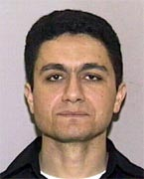

Hilarion del Rosario Santos III, alias Ahmad Santos told authorities that he had established a training camp in Pangasinan (on the island of Luzon) , which is Santos’ home. The four Al Qaeda pilots, according to Santos, got initial training in Angeles City, Pampanga before proceeding to the United States.

Santos reportedly broke down during the interrogation that his group were in contact with Osama Bin Laden’s Al Qaeda suicide squad that hijacked four US commercial planes and crashed them into two of the American famous landmarks - the World Trade Center’s Twin Towers and the Pentagon’s military intelligence headquarters. The other hijacked commercial airliner crashed into a vacant lot in Pennsylvania after passengers attempted to overpower the armed hijackers and take control of the plane hijackers who tried to hit the aircraft straight to their target - the White House in Washington DC.

Santos confessed that his group aided in training and giving shelter to the terrorists responsible in the September 11 US attack, according to an investigating officer, who was one of Santos’ interrogators.

He said their established training camp in Luzon is situated in a secluded place in Pangasinan, Santos’ home-place.

The Al-Qaeda pilots, according to him, got their first training in Angeles, Pampanga, before they proceeded to the United States to harness further their flight training in manning big commercial planes.

Itong mga Arabo, pagkaatpos ng flight training nila sa Angeles, Pampanga, umuwi sa tirahan ng RSM ni Santos sa Pangasinan (These Arabs, after their flight training in Angeles Pampanga, went back to their shelter in the home-base of Santos’ RSM in Pangasinan),” the officer revealed.

Angeles City is where Clark Airbase field is located.

The officer-investigator said Santos admitted they were behind the wave of terrorist attacks in Luzon, including the December 2004 bombing in Makati City, Metro Manila, which killed and injured scores of bus passengers.